2024 Mayor and Council Meeting Dates

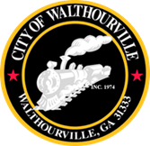
January 9, 2024
January 23, 2024
February 13, 2024
*February 26, 2024(meeting changed from Tuesday February 27, 2024)
March 12, 2024
March 26, 2024
April 9, 2024
April 23, 2024
May 14, 2024
May 28, 2024
June 11, 2024
June 25, 2024
July 9, 2024
July 23, 2024
August 13, 2024
August 27, 2024
September 10, 2024
September 24, 2024
October 8, 2024
October 22, 2024
November 12, 2024
December 10 ,2024

All Meetings are held at 6:00 PM at the Police Department and are open to the Public.

