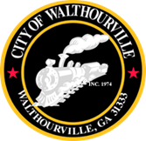
City of Walthourville

Mayor and Council GMA Meeting
April 15, 2025 @ 6:00 PM
Walthourville Police Department

AGENDA

- Call Order Mayor Sarah B. Hayes

- Roll Call City Clerk

- Georgia Municipal Association Mrs. Pam Helton
Director of Member Services

- Mayor and Council Comments City of Walthourville

- Adjournment City of Walthourville

