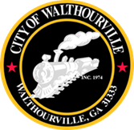
City of Walthourville
Mayor and Council Special Called Meeting
February 4, 2025 @ 6:00 PM
Walthourville Police Department

The Mayor and Council will hold a Special Called Meeting on February 4, 2025 at the Walthourville Police Department. The purpose of this meeting is to discuss the FY 2025 Budget and City Staffing Issues.

This meeting will be held from 6:00 PM-7:30 PM. This meeting is open to the public.

AGENDA
- Call to Order Mayor Sarah B. Hayes
- Roll Cal City of Walthourville
- Meeting Discussion Mayor and Council
- FY 2025 Budget
- City Staffing
- Adjournment Mayor and Council

