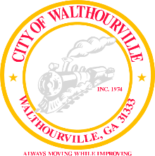
City of Walthourville
Mayor and Council Working Session
January 17, 2024 @ 6:00 PM
Walthourville City Hall

The Honorable Mayor Sarah B. Hayes, Presiding

- Call to Order: Mayor Sarah B. Hayes

- City Business Discussion Mayor and Councilmembers

- City Council Assignments Mayor Sarah B. Hayes

- Adjournment Councilmembers

