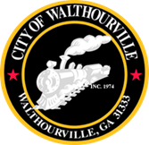
City of Walthourville
Special Called Meeting
March 5, 2025 @ 5:00 PM
Walthourville Police Department

AGENDA

- Call to Order Mayor or Mayor Pro Tem
- Roll Call City of Walthourville
- Invocation Designated Individual
- Pledge of Allegiance In Unison
- Approval of the Agenda Councilmembers
- Discussion of Master Billing Registry Councilmembers
- Discussion of Financial Records and Council Access Councilmembers
- Discussion of Procedures for accessing Master Billing Registry Councilmembers
- Consideration of resolutions and or motions to ensure compliance with transparency standards Councilmembers

- Adjournment Councilmembers

This meeting is open to the public.

