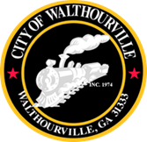
City of Walthourville
Special Called Meeting
March 5, 2025 @ 5:00 PM
Walthourville Police Department

AMENDED AGENDA
as of 03-05-2025 @ 12:54 PM

- Call to Order Mayor or Mayor Pro Tem
- Roll Call City of Walthourville
- Invocation Designated Individual
- Pledge of Allegiance In Unison
- Approval of the Agenda Councilmembers
- Discussion of Billing & Access Councilmembers
- Discussion of Compliance Standards Councilmembers

This meeting is open to the public.

