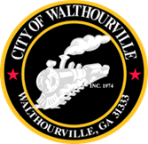
City of Walthourville
FY 2026 Budget Adoption Meeting
December 18, 2025 @ 6:00 PM
Walthourville Police Department

AGENDA

I. Call to Order Mayor Sarah B. Hayes

II. Roll Call City of Walthourville

III. Purpose of Meeting Mayor Sarah B. Hayes
The Budget for the General Fund is $3,399,683.40 and the Water Fund Budget is $2,673,003.06.

IV. Motion to Approve the FY 2026 Budget Councilmembers

V. Motion to Adjourn Councilmembers

