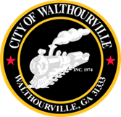
City of Walthourville
FY 2026 Public Hearing # 2
December 18, 2025 @ 6:00 PM
Walthourville Police Department

AGENDA

I. Call to Order Mayor Sarah B. Hayes
II. Roll Call City of Walthourville
III. Public Hearing Walthourville Citizens
IV. Adjournment Councilmembers

All meetings are open to the public.

